
COLLEGE OF COMPUTER STUDIES

CCS007L (COMPUTER PROGRAMMING 2)

EXERCISE
1

User Defined Functions and Parameters

Student Name / Group Name:
Jed L. Hizon
Name Role

Members (if Group):

BSCSSE – AN11
Section:

Professor:
Mr. Mark Anthony Cezar

I. PROGRAM OUTCOME/S (PO) ADDRESSED BY THE LABORATORY EXERCISE

• Analyze a complex problem and identify and define the computing requirements appropriate to its solution. [PO: B]

II. COURSE LEARNING OUTCOME/S (CLO)ADDRESSED BY THE LABORATORY EXERCISE

• Understand the fundamental principles of C-string manipulations, pointer and memory allocation and structures using C++ [CLO: 1]

III. INTENDED LEARNING OUTCOME/S (ILO) OF THE LABORATORY EXERCISE At the end of this exercise, students must be able to:
• Identify User-Defined Functions
• Identify Types of User-defined Functions in C++ • Create User defined functions in a C++ program • Understand Parameters and Arguments
• Understand Function Overloading

IV. BACKGROUND INFORMATION

Functions:
• Procedure, subprograms, and method
• A function may return a value (produce a value) or may perform some action without
returning a value.
• Functions that do not return a value are called void functions.

User defined functions
• You can define your own functions, either in the same file as main part of your program
or in a separate file so that the functions can be used by several different programs.

CCS007L-Computer Programming 2 Page 2 of 7

V. GRADING SYSTEM/ RUBRIC

Trait

Requirement Specification(30pts)

Data type(20pts)

Input Validation(20pts)

Free from syntax, logic, and runtime errors (10pts)

Delivery (10pts)

Use of Comments (10pts)
(Excellent) Able to identify
correctly all input and output and provide alternative.
(28-20pts)

Able to apply required data type or data structure and produce correct results (18-20pts)
The program works and meets all specifications. Does exception al checking for errors and out-of- range data (18-20pts) Unable to run program (10pts)

The program was delivered on time (10pts)

Specific purpose is noted for each function, control structure, input requirements, and output results. (10pts)
(Good)
Able to identify correctly all input and output
(25-17pts)

Able to apply required data type or data structure and produce partially correct results (15-17pts) The program works and meets all specifications. Does some checking for errors and out of range data (15-17pts) Able to run program but have logic error (8-9pts)

The program was delivered after 5 minutes from the time required. (8-9pts)

Specific purpose is noted for each function and control structure. (8-9pts)
(Fair)
Able to identify only one input or output (22-14pts)

Able to identify required data type or data structure but does apply correctly (12-14pts)

The program produces correct results but does not display correctly Does not check for errors and out of range data (12-14pts)
Able to run program correctly without any logic error and display inappropriate output (6-7pts)

The program was delivered after 10 minutes from the time required. (6-7pts)

Purpose is noted for each function. (6-7pts)
(Poor) Unable to
identify any input and output
(20-11pts)

Unable to identify required data type
(9-11pts)

The program produce s incorrect results (9-11pts)

Able to run program correctly without any logic error and display appropriate output (5pts) The program was delivered after 15 (or more) minutes from the time required. (5pts)
No comments included. (5pts)

CCS007L-Computer Programming 2 Page 3 of 7
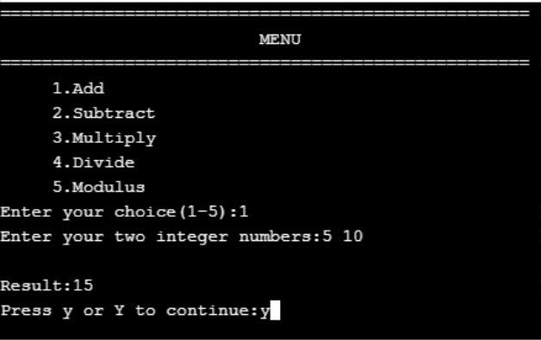

VI. LABORATORY ACTIVITY

INSTRUCTIONS:
Copy your source codes to be pasted in this document as well as a screen shot of your running output.

Activity 1.1 User defined Functions
The program will prompt the user to choose the operation choice (from 1 to 5). Then it asks the user to input two integer vales for the calculation

Example Program Output:

ACTIVITY 1.2: User-defined Functions (Passing by value)
Create a program with a user-defined function that compute the area of the following polygons and circle. You are to create one user-defined function for every computation. The functions must accept parameters by reference.

• Area of square given the side.
• Area of rectangle given the length and width. • Area of triangle given the base and height.
• Area of circle given the radius.

CCS007L-Computer Programming 2 Page 4 of 7
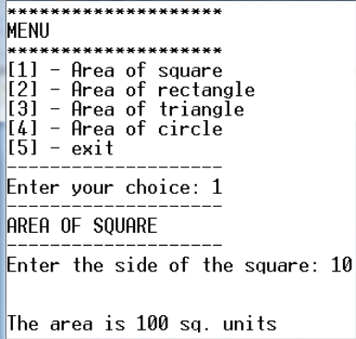
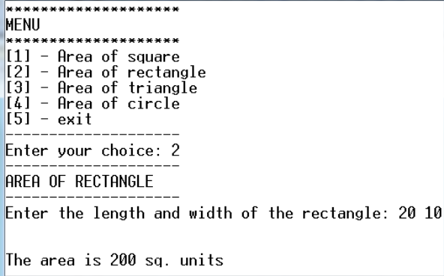
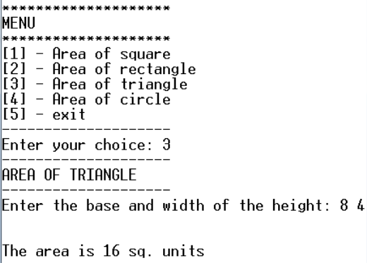
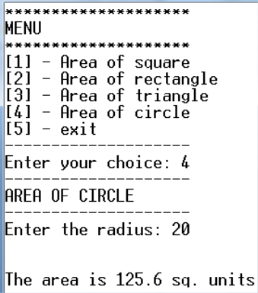
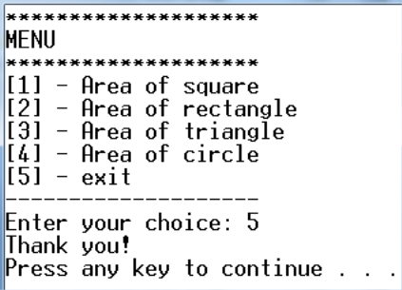

EXAMPLE PROGRAM OUTPUT:

CCS007L-Computer Programming 2 Page 5 of 7

Snip and paste your source codes here. Snip it directly from the IDE so that colors of the codes are preserved for readability. Include additional pages if necessary.

Activity 1.1

#include <iostream>
using namespace std;

void Options();
int getOperator(int choice);
int solveNumbers(int choice, int input1, int input2);

int main(){
char cont;
do{
int choice = 0, num1 = 0, num2 = 0, result = 0;

system("cls");
Options();

cout << "Enter your choice (1-5): "; cin >> choice;
if(choice >= 1 && choice <= 5){
cout << "Enter your two interger numbers: "; cin >> num1 >> num2;

result = solveNumbers(choice, num1, num2);
cout << "Result: " << result << endl << endl;

cout << "Would you like to solve for another set of numbers? (y/n) "; cin >> cont;
}

else{
cout << "Invalid Operator! \n\nWould you like to try again?(y/n) ";
cin.clear();
cin.ignore();
cin >> cont;
}
}
while(cont == 'Y'||cont == 'y');
cout << "\nEND";

return 0;
}

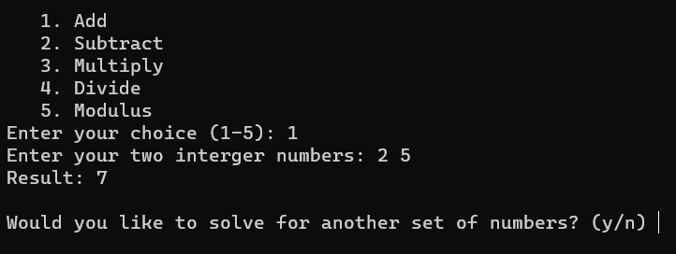

void Options(){
cout << " 1. Add" << endl;
cout << " 2. Subtract" << endl;
cout << " 3. Multiply" << endl;
cout << " 4. Divide" << endl;
cout << " 5. Modulus" << endl;
}

int solveNumbers(int choice, int input1, int input2){
int result;

switch(choice){
case 1:
result = input1 + input2;
break;
case 2:
result = input1 - input2;
break;
case 3:
result = input1 * input2;
break;
case 4:
result = input1 / input2;
break;
case 5:
result = input1 % input2;
break;
}
return result;
}

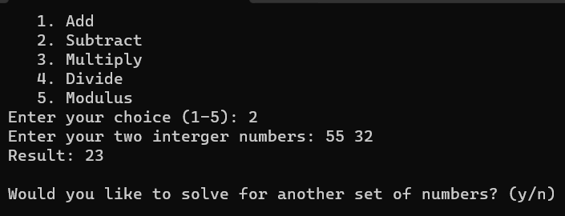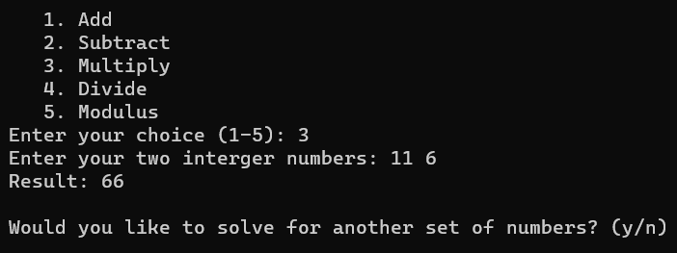
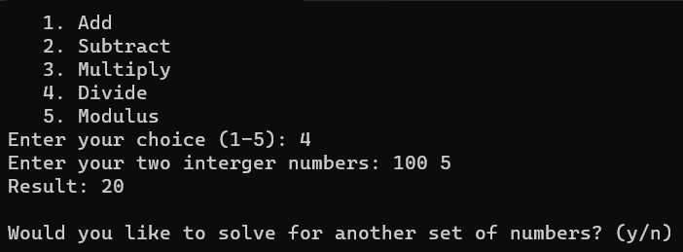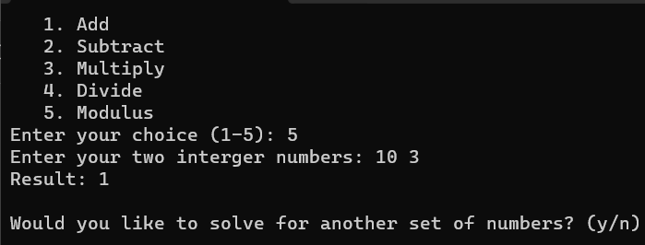
Activity 1.2
#include <iostream>
#include <cmath>
using namespace std;

void lineAsterisk();
void lineDash();
void menu();
double solveSquare(double input1);

int main(){
char choice;
double input1=0, input2=0, result=0;

do{
menu();
cout << endl << "Enter your choice: "; cin >> choice;
lineDash();

switch(choice){
case '1':
cout << "AREA OF SQUARE" << endl;
lineDash();
cout << "Enter the side of the square: "; cin >> input1;
cout << endl << "The area is " << pow(input1, 2) << " sq. units";
break;

case '2':
cout << "AREA OF RECTANGLE" << endl;
lineDash();
cout << "Enter the length and width of the rectangle: "; cin >> input1 >> input2;
result = input1 * input2;
cout << endl << "The area is " << result << " sq. units";
break;

case '3':
cout << "AREA OF TRIANGLE" << endl;
lineDash();
cout << "Enter the base and width of the height: "; cin >> input1 >> input2;
result = (input1 * input2)/2;
cout << endl << "The area is " << result << " sq. units";
break;
case '4':
cout << "AREA OF CIRCLE" << endl;
lineDash();
cout << "Enter the radius: "; cin >> input1;
result = M_PI * pow(input1, 2);
cout << endl << "The area is " << result << " sq. units";
break;
case '5':
cout << "Thank You!" << endl;
return 0;
break;

default:
cout << "INVALID INPUT!";
}
}
while(choice != '5');

return 0;
}
void lineAsterisk(){
for(int i; i < 20; i++){
cout << "*";
}
}
void lineDash(){
for(int i; i < 20; i++){
cout << "-";
}
cout << endl;
}

void menu(){
cout << endl;
lineAsterisk();
cout << endl << "MENU" << endl;
lineAsterisk(); cout << endl;
cout << "[1] - Area of Square" << endl;
cout << "[2] - Area of Rectangle" << endl;
cout << "[3] - Area of Triangle" << endl;
cout << "[4] - Area of Circle" << endl;
cout << "[5] - Exit" << endl;
lineDash();
}

VII.QUESTION AND ANSWER

Briefly answer the questions below. Avoid erasures. For group activity, specify the name of GROUP MEMBER/s who answered the question. Do not forget to include the source for all NON-ORIGINAL IDEAS.

• What is a Function? What are the advantages of using it?

• What is the difference between predefined function and user defined function?
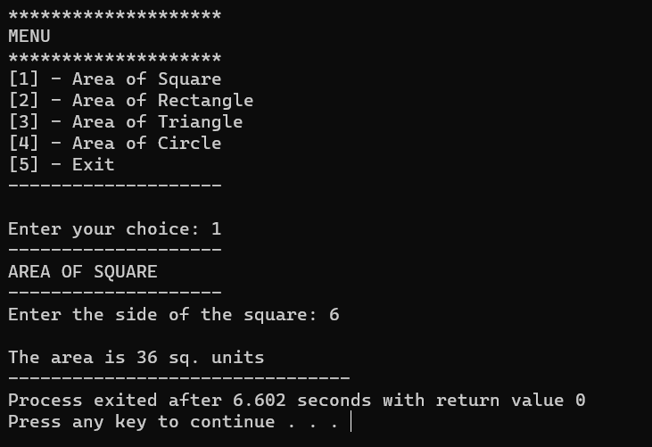
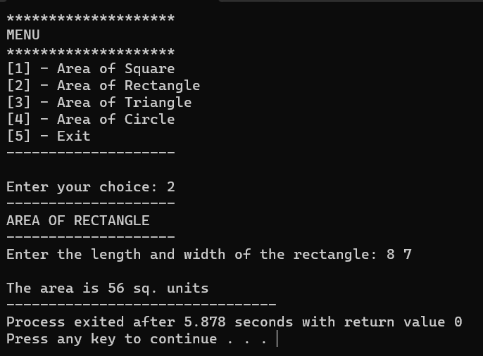

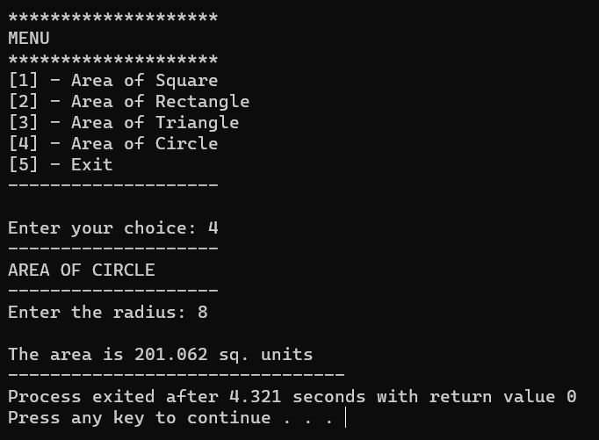
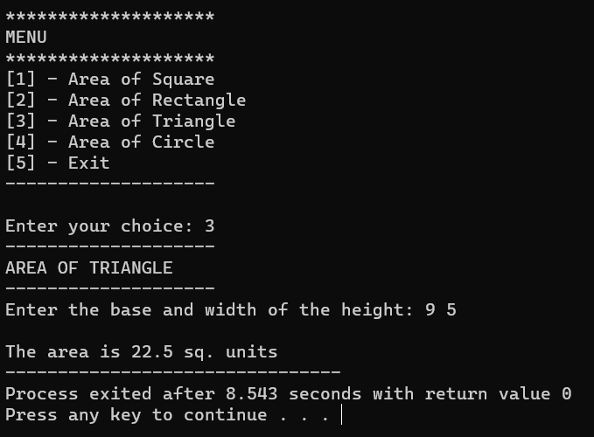

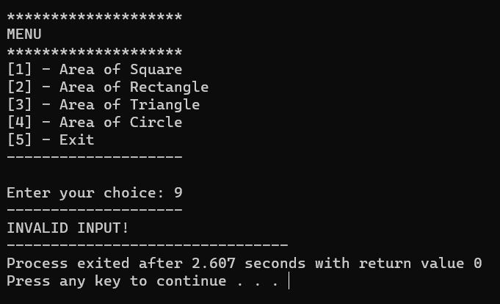
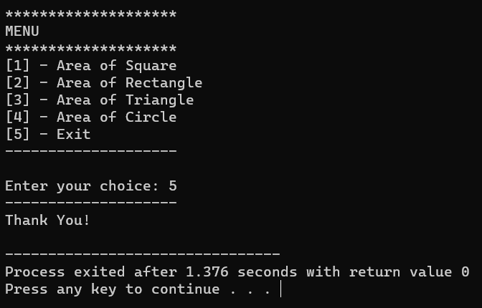

VIII. REFERENCES
• Zak, Dianne (2016). An Introduction to Programming with C++
• Deitel, Paul & Deitel, Harvey (2012). C++ How To Program, Eighth Edition • https://www.cprogramming.com/tutorial/lesson4.html

CCS007L-Computer Programming 2 Page 7 of 7

